**PATIENT INFORMATION**

First Name: **_____________________**Middle**: ________**Last Name:____________________________________  
  
Date of Birth: _____________________ Age: __________Sex: F □ M □   
  
Marital Status: S □ M □ D □ W □ Email**:** ____________________________**_________________________**  
  
Employer: _________________________________________________________________________________  
  
Race: ________________ Ethnicity**:** □ Non-Hispanic □ Hispanic Primary Language: ____________________

Street Address:_____________________**___________**City/State/Zip:__________________________________

Mailing Address (If Different): **________________________________________________________________**

City/State/Zip: **_____________________________________________________________________________**

Home:____________________________________ Cell:____________________________________________

**RESPONSIBLE PARTY INFORMATION (if different from above)**

Last Name: ___________________________________ First Name: __________________________________

SSN:_____________________________________________________________________________________

Address: **__________________________________________________________________________________** City/State/Zip:**________________________________________________________**

Home: **______________________**Work: **________________________** Cell: **__________________________**

Date of Birth: ________________________ Relationship to Patient: _________________________________

**MEDICAL INSURANCE**

**Primary Insurance Company**: **_______________________________________________________________**

Group:____________________________________ID:_____________________________________________

Subscriber Name:**___________________________________________** Subscriber DOB:_________________

Subscriber Relationship to Patient ____________**__________________□ Subscriber is the same as the patient**

**Secondary Insurance Company**: **_______________________________________________________________**

Group:____________________________________ID:_____________________________________________

Subscriber Name:**___________________________________________** Subscriber DOB:_________________

Subscriber Relationship to Patient ____________**__________________□ Subscriber is the same as the patien**

**CLINIC BILLING AND EXPECTATIONS**

Please sign below to indicate you have read and understand the following:

1. Responsibility for payment of your account remains with you at all times; and although you may have a pending insurance claim, we will require you to pay regardless of the circumstances involved. Please contact us immediately if there is a problem with your claim or a third party payer.
2. Copays and other estimated out of pocket amounts due are to be collected at the time of service.
3. CASH PAY POLICY: Patients without medical insurance are required to pay at the time of service prior to appointment. Please note your balance will be determined based on actual services rendered during your office visit. Company who provides labs and imaging will bill separately.
4. You will receive a monthly statement showing itemized charges and the total amount due on your account. Payment in full is required within 30 days of the statement date, unless arrangements are made with our billing office.
5. There is a $35 fee for stop payments.
6. If your account has been referred to a collections agency, you will be dismissed from this clinic.
7. If you arrive late to an appointment, you may be asked to reschedule.
8. If you cannot make your appointment, you must call and cancel 24 hours before scheduled appointment time.
9. Patient *no show* to a scheduled appointment will be sent a warning letter on first occurrence. Any subsequent *no show* you will be charged a $75 fee or be dismissed from the practice.
10. Pain GPS Clinic requires 5 business days to respond to all medication refill requests. Medications will not be refilled after clinic hours. Please contact your pharmacy to initiate refill requests.
11. After Hours: There is no provider on call after business hours. If you are in need of medical attention you must go to your local Urgent Care or Emergency Room.

**CONSENT FOR TREATMENT**

By signing below, I am requesting Pain GPS Clinic provide health care related treatment and consolation to the below named patient, and that I may refuse treatment or services at any time. I understand Pain GPS Clinic does not guarantee any outcome for any services or treatments, either stated or implied.

**Patient Name: __________________________________________DOB:______________**

**Signature________________** **Date:______**

**MEDICAL HISTORY:**

□ Heart Disease □ Stroke □ Cancer □ Arthritis □ Diabetes □ Hypertension □ Asthma

□ Thyroid □ Anxiety □ Depression □ Bleeding Disorders

□ Other_________________________________________________________________

**PAST SURGICAL HISTORY:** List all surgical procedures you have had (include pacemaker/defibrillator, joint replacement/fusion or vascular stints) and the date:

|  |  |
| --- | --- |
| **Year** | **Procedure** |
|  |  |
|  |  |
|  |  |
|  |  |

**DIAGNOSTIC STUDIES:**

|  |  |  |
| --- | --- | --- |
| **Type of Imaging** | **Date (month/year)** | **Body Part** |
| **Xray** |  |  |
| **MRI** |  |  |
| **Other:** |  |  |

**CURRENT CARE PROVIDERS:**

|  |  |
| --- | --- |
| Physical Therapist:  Chiropractor: |  |
| Neurologist: |  |
| Neurosurgeon:  General Surgeon:  Orthopedic: |  |
| Cardiologist: |  |
| Urologist: |  |
| Psychiatrist:  Psychologist:  Counselor: |  |
| Rheumatologist: |  |
| Endocrinologist |  |
| Previous Pain Management Provider or office: |  |

**SOCIAL HISTORY:**

Employment:□ full time/part time/prn □ Unemployed □ Retired □ Disabled □ Other__________

Marital Status: □ Single □ Married □ Divorced □ Widowed □ Separated

Has your marital status changed since your pain problem began? □ Yes □No

Residence: □House □Apartment □Condo □Mobile Home □Experiencing Housing Insecurity

Number of people living with you: ______Number of children living with you: _________

Do you have a pet? □ No □Yes (list):___________________________________________

Do you use a CPAP machine? □ No □Yes

Do you use oxygen? □ No □Yes If yes:_______ L/min □always □only as needed

**HABITS**:

How many hours do you sleep at night?___________

Is the sleep you get restorative or restful? □ Yes □No

What sleep aids do you take? □ No □Yes (list in meds list)

Do you drink caffeinated beverages?□ Yes □ No If yes, how much per day: ____________________

Do you smoke or use tobacco in any form? □ Yes □ No Packs/day? ____ # years_________

Do you drink alcoholic beverages?□ Yes □ No How many drinks/day? ____________________

Do you use any recreational or street drugs? □ Never □ In the past but not now □ Yes

If yes which one: □ Alcohol □Barbiturates □ Cocaine □ Heroin □ Amphetamines □ Marijuana

How often? □Seldom □Sometimes □Often

**FAMILY HISTORY:**

Has anyone in your family suffered from chronic pain? □ No □Yes If yes, what condition: _____________________________________________________________________________

Do your biological mother, father, brother, sister, aunt, uncle have:

□ Heart Disease □ Stroke □ Cancer □ Arthritis □ Diabetes □ Hypertension □ Asthma

□ Thyroid □ Anxiety □ Depression □ Bleeding Disorders

□ Other_________________________________________________________________

Are your mother, father, brother, sister deceased? □ No □Yes If yes, what was the cause

|  |  |  |  |  |
| --- | --- | --- | --- | --- |
| **Allergies:** | □ No known drug allergies □ Yes (list):___________________________________________________  □ No known drug intolerance □ Yes (list):___________________________________________________ | | | |
| **Current Medications** (attach sheet if needed): Strength? Times per day? Months, years? | | | | |
|  | |  |  |  |
|  | |  |  |  |
|  | |  |  |  |
|  | |  |  |  |
|  | |  |  |  |
|  | |  |  |  |
|  | |  |  |  |

**List 3 goals of treatment: ___________________________________________________________________________________________________________________________________________________________________________________________________________________________________________________**

**What meds have you tried in the past to manage the pain you are seeking attention for today?**

|  |  |  |  |  |  |
| --- | --- | --- | --- | --- | --- |
| **Use Now** | **Used Before** | **Medication** | **Use Now** | **Used Before** | **Medication** |
|  |  | **Narcotics & Opiates:** |  |  | **Sleeping Aids:** |
|  |  |  |  |  |  |
|  |  |  |  |  |  |
|  |  |  |  |  |  |
|  |  |  |  |  |  |
|  |  |  |  |  |  |
|  |  | **Anti-Inflammatories:** |  |  | **Antidepressants:** |
|  |  |  |  |  |  |
|  |  |  |  |  |  |
|  |  |  |  |  |  |
|  |  |  |  |  |  |
|  |  |  |  |  |  |
|  |  | **Tranquilizers:** |  |  | **Anti-Convulsants and Nerve Pain:** |
|  |  |  |  |  |  |
|  |  |  |  |  |  |
|  |  |  |  |  |  |
|  |  |  |  |  |  |
|  |  |  |  |  |  |
|  |  | **Migraine Medications:** |  |  | **Over the Counter Medications:** |
|  |  |  |  |  |  |
|  |  |  |  |  |  |
|  |  |  |  |  |  |
|  |  |  |  |  |  |
|  |  | **Other medications for pain:** |  |  |  |
|  |  |  |  |  |  |
|  |  |  |  |  |  |
|  |  |  |  |  |  |
|  |  |  |  |  |  |

**PAST PAIN TREATMENTS:**

|  |  |  |  |  |
| --- | --- | --- | --- | --- |
| **Treatment** | **Never Tried** | **Yes, I have done this and the effect was:** | **Effect lasted** | **When** |
| **Surgery (what type?)** |  | None Mild Moderate Excellent |  |  |
| **Injection (what type?)**  **Trigger point**  **Nerve block**  **Facet injection**  **RFA** |  | None Mild Moderate Excellent |  |  |
| **Physical Therapy** |  | None Mild Moderate Excellent |  |  |
| **Chiropractor** |  | None Mild Moderate Excellent |  |  |
| **Acupuncture** |  | None Mild Moderate Excellent |  |  |
| **Massage** |  | None Mild Moderate Excellent |  |  |
| **Behavioral Therapy** |  | None Mild Moderate Excellent |  |  |

**MARK AREAS ON BODY WHERE YOU FEEL THE DESCRIBED SENSATIONS**:

Use the following symbols. Marks areas of radiation. Include all affected areas.

Numbness (====) Pins & Needles (00000) Burning (XXXX) Stabbing (/////) Shooting/Radiating (→→)

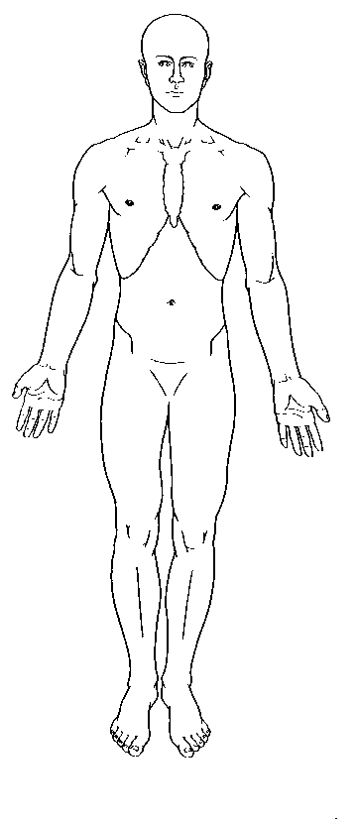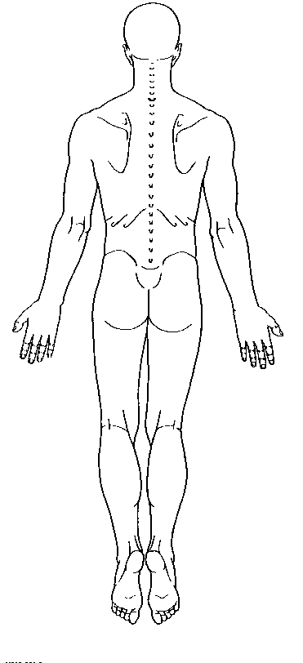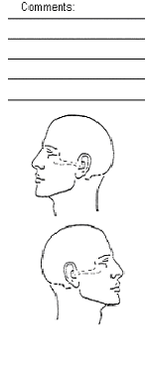

**My pain is present**: □Constantly □Intermittently □On a daily basis □Only in ______am _____pm

□Only with walking □Weekly □Only with activity such as __________________________________

**My pain is best described as**: □Tender □Dull □Aching □Throbbing □Sharp □Stabbing □Shooting □Burning □Penetrating □Nagging □Numbness □Exhausting □Miserable □Tiring □Unbearable

**My pain is the result of**: □Unknown □After lifting heavy objects □MVA □Shingles □Work-Related

□Falling □Sports injury □Physical altercation □Surgery □Disease □Other

|  |  |  |  |
| --- | --- | --- | --- |
| **How do the following affect your pain:** | **Decrease** | **No change** | **Increase** |
| **Lying Down** |  |  |  |
| **Standing** |  |  |  |
| **Sitting** |  |  |  |
| **Walking** |  |  |  |
| **Exercise** |  |  |  |
| **Relaxation** |  |  |  |
| **Coughing/Sneezing** |  |  |  |
| **Push/Pull** |  |  |  |
| **Bend** |  |  |  |

**SOAPP®-R**

|  |  |  |  |  |  |
| --- | --- | --- | --- | --- | --- |
| **Name/DOB:** | Never | Seldom | Sometimes | Often | Very Often |
| How often do you have mood swings? | 0 | 1 | 2 | 3 | 4 |
| How often have you felt a need for higher doses of medication to treat your pain? | 0 | 1 | 2 | 3 | 4 |
| How often have you felt impatient with your doctors? | 0 | 1 | 2 | 3 | 4 |
| How often have you felt things are just too overwhelming that you can’t handle them? | 0 | 1 | 2 | 3 | 4 |
| How often is there tension at home? | 0 | 1 | 2 | 3 | 4 |
| How often have you counted pain pills to see how many are remaining? | 0 | 1 | 2 | 3 | 4 |
| How often have you been concerned that people will judge you for taking pain medication? | 0 | 1 | 2 | 3 | 4 |
| How often do you feel bored? | 0 | 1 | 2 | 3 | 4 |
| How often have you taken more pain medication than you were supposed to? | 0 | 1 | 2 | 3 | 4 |
| How often have you worried about being left alone? | 0 | 1 | 2 | 3 | 4 |
| How often have you felt a craving for medication? | 0 | 1 | 2 | 3 | 4 |
| How often have others expressed concern over your use of medication? | 0 | 1 | 2 | 3 | 4 |
| How often have any of your close friends had a problem with alcohol or drugs? | 0 | 1 | 2 | 3 | 4 |
| How often have others told you that you had a bad temper? | 0 | 1 | 2 | 3 | 4 |
| How often have you felt consumed by the need to get pain medication? | 0 | 1 | 2 | 3 | 4 |
| How often have you run out of pain medication early? | 0 | 1 | 2 | 3 | 4 |
| How often have others kept you from getting what you deserve? | 0 | 1 | 2 | 3 | 4 |
| How often, in your lifetime, have you had legal problems or been arrested? | 0 | 1 | 2 | 3 | 4 |
| How often have you attended an AA or NA meeting? | 0 | 1 | 2 | 3 | 4 |
| How often have you been in an argument that was so out of control that someone got hurt? | 0 | 1 | 2 | 3 | 4 |
| How often have you been sexually abused? | 0 | 1 | 2 | 3 | 4 |
| How often have others suggested that you have a drug or alcohol problem? | 0 | 1 | 2 | 3 | 4 |
| How often have you had to borrow pain medications from your family or friends? | 0 | 1 | 2 | 3 | 4 |
| How often have you been treated for an alcohol or drug problem? | 0 | 1 | 2 | 3 | 4 |

**Pain Catastrophizing Scale**

We are interested in the types of thoughts and feeling that you have when you are in pain. Listed below are thirteen statements describing different thoughts and feelings that may be associated with pain. Using the scale, please indicate the degree to which you have these thoughts and feelings when you are experiencing pain.

|  |  |  |  |  |  |
| --- | --- | --- | --- | --- | --- |
|  | **Not at all** | **To a slight degree** | **To a moderate degree** | **To a great degree** | **All the time** |
| I worry all the time about whether the pain will end | 0 | 1 | 2 | 3 | 4 |
| I feel I can’t go on | 0 | 1 | 2 | 3 | 4 |
| It’s terrible and I think it’s never going to get better | 0 | 1 | 2 | 3 | 4 |
| It’s awful and I feel that it overwhelms me | 0 | 1 | 2 | 3 | 4 |
| I feel I can’t stand it anymore | 0 | 1 | 2 | 3 | 4 |
| I become afraid the pain will get worse | 0 | 1 | 2 | 3 | 4 |
| I keep thinking of other painful events | 0 | 1 | 2 | 3 | 4 |
| I anxiously want the pain to go away | 0 | 1 | 2 | 3 | 4 |
| I can’t seem to keep it out of my mind | 0 | 1 | 2 | 3 | 4 |
| I keep thinking about how much it hurts | 0 | 1 | 2 | 3 | 4 |
| I keep thinking about how badly I want the pain to stop | 0 | 1 | 2 | 3 | 4 |
| There’s nothing I can do to reduce the intensity of the pain | 0 | 1 | 2 | 3 | 4 |
| I wonder whether something serious may happen | 0 | 1 | 2 | 3 | 4 |

**Patient Health Questionnaire (PHQ-9)**

**Over the last two weeks, how often have you been bothered by any of the following problems?**

|  |  |  |  |  |
| --- | --- | --- | --- | --- |
|  | Note at all | Several days | More than half the days | Nearly every day |
| Little interest or pleasure in doing things | 0 | 1 | 2 | 3 |
| Feeling hopeless, down, depressed, or hopeless | 0 | 1 | 2 | 3 |
| Trouble falling or staying asleep, or sleeping too much | 0 | 1 | 2 | 3 |
| Feeling tired or having little energy | 0 | 1 | 2 | 3 |
| Poor appetite or overeating | 0 | 1 | 2 | 3 |
| Feeling bad about yourself – or that you are a failure or have let yourself or your family down | 0 | 1 | 2 | 3 |
| Trouble concentrating on things, such as reading the newspaper or watching television | 0 | 1 | 2 | 3 |
| Moving or speaking so slowly that other people could have noticed. Or the opposite –being so fidgety or restless that you have been moving around a lot more than usual | 0 | 1 | 2 | 3 |
| Thoughts that you would be better off dead, or of hurting yourself | 0 | 1 | 2 | 3 |
| If you checked off any problems, how difficult have these problems made it for you to do your, take care of things at home, or get along with other people? | Not difficult at all | Somewhat difficult | Very difficult | Extremely difficult |

**Total Score___________________**